# Paper I

Tjiptomongsoguno, A.R.W., Chen, A., Sanyoto, H.M., Irwansyah, E., Kanigoro, B. (2020). Medical Chatbot Techniques: A Review. In: Silhavy, R., Silhavy, P., Prokopova, Z. (eds) Software Engineering Perspectives in Intelligent Systems. CoMeSySo 2020. Advances in Intelligent Systems and Computing, vol 1294. Springer, Cham. <https://doi.org/10.1007/978-3-030-63322-6_28> <https://link.springer.com/chapter/10.1007/978-3-030-63322-6_28#Abs1>

* This paper provides good motivation for use of medical chatbots.
* We know that NLP and ML are the best methods for achieving this.

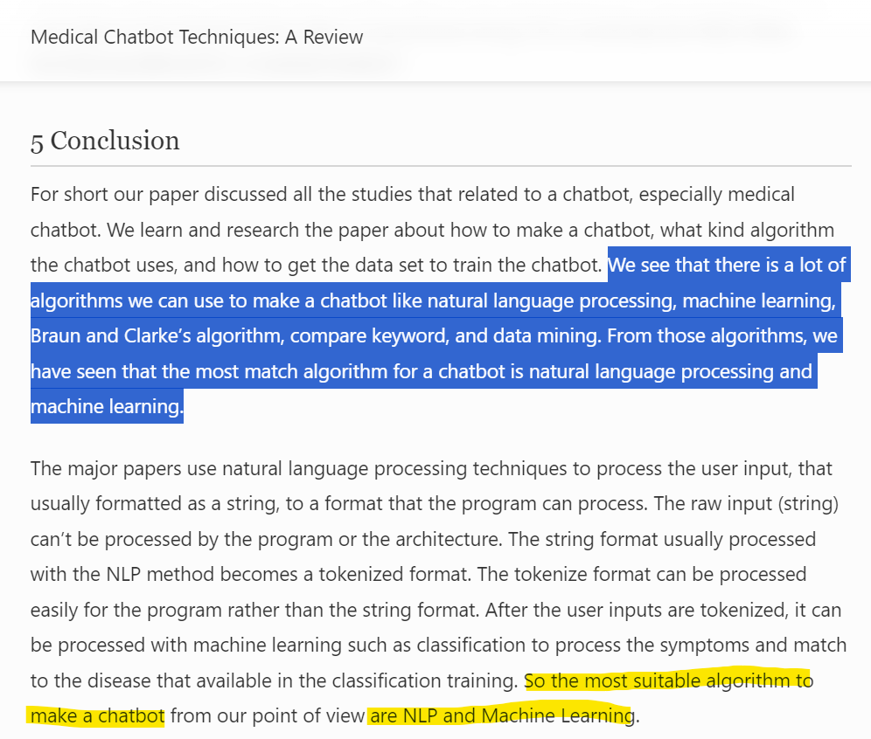

# Paper II

Rosruen, N., & Samanchuen, T. (2018). Chatbot Utilization for Medical Consultant System. 2018 3rd Technology Innovation Management and Engineering Science International Conference (TIMES-iCON). doi:10.1109/times-icon.2018.8621678

<https://www.opendream.co.th/en/project/doctorme-en> This app helps users on what to do when experiencing *x* symptom. It's a self-care app

* The idea motivation is similar to the previous paper.
* This paper proposes the use of auto-response systems, like those used in online businesses.
* The focus of this paper is to implement a successful human-app interaction (DoctorMe) as a chatbot.

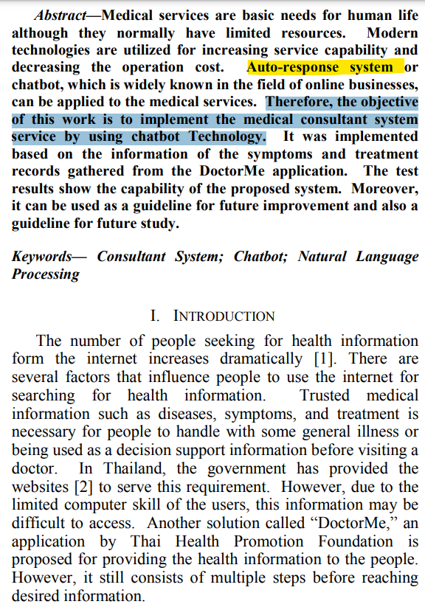

# Paper III

<https://d1wqtxts1xzle7.cloudfront.net/61052907/reportmedical_chatbot20191028-44031-hq2g2a-libre.pdf?1572328148=&response-content-disposition=inline%3B+filename%3DA_Medical_ChatBot.pdf&Expires=1691223442&Signature=Z45aeEkFQeZgwQLjX6vxGDBJbfmlF~LGKxSzOBKCgvpcvMYwsqs8TljLE-Ll62qsJ-xUjFx60SksKTCcjIHNKnfo~-7jX4ZM-E1-ZwB~g5mHDUE90aFtWmXLW6zXSdu8VkR~LW4Zd9KeHBG441cfcgAqh-nUac8A0948rzNQfqyfpCiJ1x1rC1uW6mIdAwkprUaySVXvlMc0IOPxI~4r63BT~eaBWNLP385GLYG0c8GbTrD0I5--9O35gV9N9495azOjSJofKRNkbFIG27bS22ZZUMeFfnYTPZrmOtf-TIvroBHg~BPC61WCChIMZ-Tx9s1x1jweYaBf5z-iL-~u2Q__&Key-Pair-Id=APKAJLOHF5GGSLRBV4ZA> A Medical Chatbot

* This paper suggests a more accessible interface, with voice and face recognition.

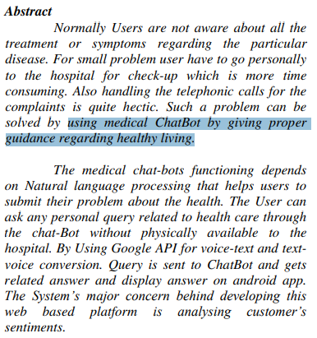

# Reference IV

<https://sites.research.google/med-palm/>

<https://arxiv.org/pdf/2305.09617.pdf>

* Med-PaLM 2 generates accurate, helpful long-form answers to consumer health questions. It achieves an accuracy of 86.5% on USMLE-style questions
* Future: multimodal version can communicate information from X-rays, mammograms, etc.

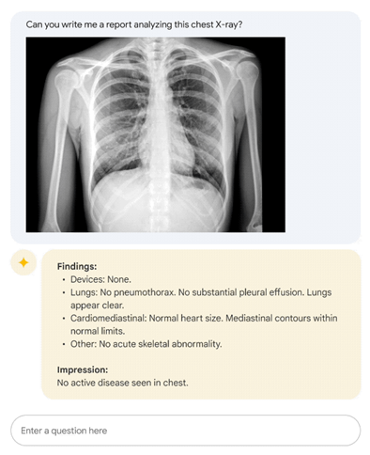

# Reference V

Gentner, T., Neitzel, T., Schulze, J., & Buettner, R. (2020). A Systematic Literature Review of Medical Chatbot Research from a Behavior Change Perspective. 2020 IEEE 44th Annual Computers, Software, and Applications Conference (COMPSAC). doi:10.1109/compsac48688.2020.0-172 <https://ieeexplore.ieee.org/abstract/document/9202698> A Systematic Literature Review of Medical Chatbot Research from a Behavior Change Perspective

* This paper reviews chatbots from a behavioral point of view.

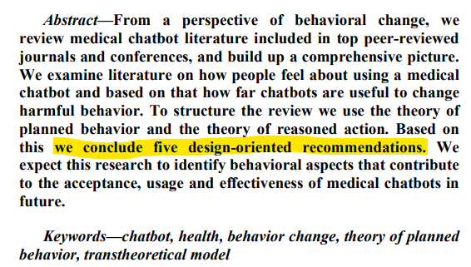

# Reference VI

<https://pubs.rsna.org/doi/10.1148/radiol.212213> Deep Learning Detection of Active Pulmonary Tuberculosis at Chest Radiography Matched the Clinical Performance of Radiologists

unimportant

Graduation Project Idea Proposal

# Idea Motivation

* People already Google their symptoms before visiting a doctor. But doctors don’t like this because the search results are out of context and inaccurate. How might we help patients get a faster and more accurate diagnosis?
* Visting the doctor is an arduous process, and it takes too much time. Between appointments, cancellations, revisits, a patient may get caught up in the process and not receive the care they need in diligent time. How might we help patients receive the help they need without too much time delay? (automated virtual assistants)
* It is easier to speak about your own experience.

Chatbots are also easier to use than online symptom checkers because people can simply describe their experience rather than shoehorning it into programs that compute the statistical likelihood of a disease.

* A Mystery in the E.R.? Ask Dr. Chatbot for a Diagnosis.

At a medical school in Boston, instructors are using ChatGPT in training exercises to help teach students how to think like doctors. Instructors like Dr. Rodman hope that medical students can turn to GPT-4 and other chatbots for something similar to what doctors call a curbside consult — when they pull a colleague aside and ask for an opinion about a difficult case. The idea is to use a chatbot in the same way that doctors turn to each other for suggestions and insights.

How do doctors diagnose?

In medicine, it’s called an illness script: signs, symptoms and test results that doctors put together to tell a coherent story based on similar cases they know about or have seen themselves.

If the illness script doesn’t help, Dr. Rodman said, doctors turn to other strategies, like assigning probabilities to various diagnoses that might fit.

GPT-4 is different. “It will create something that is remarkably similar to an illness script,” Dr. Rodman said.

To use the bot correctly, the instructors said, they would need to start by telling GPT-4 something like, “You are a doctor seeing a 39-year-old woman with knee pain.” Then, they would need to list her symptoms before asking for a diagnosis and following up with questions about the bot’s reasoning, the way they would with a medical colleague.

chatbots can “hallucinate” — provide answers with no basis in fact. Using them requires knowing when it is incorrect.